How do OPEC announcements affect oil prices and volatility?

Abstract
This dissertation examines how three key OPEC decisions on production volumes—cut, increase, and maintaining current levels—affect the oil returns and volatility of crude oil prices. The study uses a comprehensive econometric methodology and a huge array of data on daily spot prices for Brent and West Texas Intermediate (WTI) crude oil for the period from 2002 to 2025. The methodology combines a set of GARCH models, such as EGARCH and TGARCH, with an event study framework for analysing oil returns. To account for oil prices volatility clustering and asymmetric market reactions, conditional volatility is estimated via GARCH models, and its square root is included in ordinary least square and quantile regressions. The results show a noticeable asymmetry in market reactions for both oil returns and oil price volatility. Furthermore, the analysis shows that a significant portion of volatility is anticipatory in nature, with significant spikes in volatility occurring in the days leading up to OPEC announcements, indicating that market expectations are the main driver. The study also highlights important differences between the WTI and Brent benchmarks, noting how differently they respond to global supply indicators and speculative activity. The results of the study highlight the importance of considering market expectations and the varying dynamics of different benchmarks when developing hedging and investment strategies in the energy market.

Introduction
Crude oil is a vital component of the global economy as it is a critical input for transportation and industrial production, as well as a key macroeconomic indicator of investment and inflation. Oil prices are constantly in the spotlight, as changes in them have a significant impact on economic growth, inflation, as well as international political stability and financial markets. Consequently, market participants, decision-makers, and academics closely monitor fluctuations in its price. The cartel of oil-producing countries known as the Organization of Petroleum Exporting Countries (OPEC) plays an important role in oil market. OPEC has sought to coordinate the energy policies of its member countries since its establishment in 1960 to stabilize markets and ensure stable oil supplies. OPEC's collective decisions, especially those related to production quotas, are closely monitored and often lead to major changes in the dynamics of the oil market. This dissertation examines the complex and counter-intuitive relationships between OPEC statements and crude oil prices and their volatility and provides a thorough empirical analysis of how the market interprets and responds to these actions.
As given in in Section two of this study which discusses prior papers regarding oil prices and their volatility, it refers to the magnitude of price fluctuations over time and is a critical measure of risk. The factors driving this oil prices and their volatility are critical to effective risk management, forecasting, and policy development in the energy sector and beyond. Previous studies have examined the impact of OPEC actions on oil prices and their volatility, but the results have often been contradictory and dependent on the methods used. For example, while some studies used time series models such as GARCH to assess persistent effects, other studies focused on event-based methods to capture rapid changes. The distinction between OPEC's proactive policy decisions and its reaction to current market conditions is a constant problem in the literature; this endogeneity problem may obscure the real causal influence of the organization. The complexity of OPEC's influence is highlighted by theoretical debates about its functions, including whether it serves as a producer-regulator, a true cartel, or simply a signal generator. Furthermore, this renewed analysis of the relationship is highly relevant given recent developments in the oil market, including the emergence of the OPEC+ coalition and new dynamics in supply and demand.
This Section three of this dissertation seeks to build on this existing body of work by employing a rigorous, wide-ranging approach. The set of GARCH models and event study methodology are the two main econometric approaches used in the study to analyse the impact of OPEC statements. A study analysing daily spot prices for two crude oil benchmarks — West Texas Intermediate (is referred as WTI in short) and Brent over a long period from 2002 to 2025, offers a comprehensive and up-to-date perspective that considers significant market events such as the COVID-19 pandemic in 2020 and the financial crisis of 2008.
The existence and statistical significance of abnormal returns around OPEC meetings are methodically estimated on oil prices using an event study methodology that shows both short-term market reactions and potential long-term consequences. GARCH models are employed to assess the impact of OPEC announcements on both oil prices and volatility. Stylised features of financial time series, such as volatility clustering and asymmetric reactions to positive and negative shocks, are reflected in GARCH models, which include standard GARCH, EGARCH, and TGARCH models. Since EGARCH and TGARCH models are designed to identify the “leverage effect” that occurs when “bad news” (such as a reduction in supply, which is seen as a sign of weak demand) causes greater volatility than “positive news” of the same magnitude, their selection is particularly important. The study extends the GARCH analysis using both quantile regression and ordinary least squares (OLS) to examine market behaviour beyond the baseline average impact more thoroughly on oil price volatility. This is an important methodological step, as OLS models may fail to capture significant details because they only consider the average impact on volatility. On the other hand, quantile regression provides a more accurate picture of market asymmetry and allows for a more nuanced understanding of how OPEC decisions affect volatility in different market regimes, from periods of low and moderate volatility to periods of high market uncertainty.
This study attempts to examine several important issues that are the subject of professional and academic debate in energy economics. First, are there distinct and asymmetric consequences for oil prices and volatility resulting from different OPEC announcements, such as production cuts, increases, or decisions to maintain production levels? Secondly, do these impacts indicate a more gradual assimilation of knowledge over time, or are they short-lived and temporary? Third, how do the two main benchmarks—WTI and Brent—reflect their different market structures and global importance in terms of market reactions and underlying volatility dynamics? The results which are presented in Section 4 of the study, will contribute to the ongoing academic debate on OPEC's market dominance, the informational efficiency of oil markets, and the decisive role of expectations in determining price dynamics.
The findings of this study are important for various stakeholders and are presented in Section 5, together with conclusions and recommendations for future research. The study results highlight the importance of understanding asymmetric reactions to oil returns and predictable volatility patterns around OPEC meetings for market participants such as risk managers. This finding has practical implications for the pricing of options and the use of volatility-sensitive products. Furthermore, due to their inconsistent response to OPEC signals, a thorough comparison of WTI and Brent shows some important trends for market participants. To navigate market risks and opportunities in an increasingly complex energy environment, this study will offer a fresh, data-driven perspective on the complex and evolving relationship between OPEC and the global oil market.

2. Literature review
The purpose of this literature review is to summarize existing studies examining the relationship between OPEC decisions and oil market fluctuations. This review will critically observe both theoretical approaches and empirical evidence, particularly those methodologies suitable for capturing the immediate and evolving impact of discrete events. The study utilizes an expanded database of OPEC announcements grouped by production, no change and cut decisions.

2.1 OPEC as a cartel, swing producer, or a signal sender?
Oil markets primarily operate through spot markets and future exchanges, affected by economic events, geopolitical tensions, supply chain events and inventory, or speculations. Theoretically, oil is like any storable commodity, as its price determinant is both current fundamentals and expectations about future supply and demand. However, oil prices are far from perfect competitive markets. They are heavily dominated by a few large producers, such as OPEC and its allies, who practice strategic behaviour akin to oligopolistic control (Kilian, 2009; Pierru et al., 2018). The oil market is sensitive to changes in supply policies, whether realized or expected. OPEC's influence on the world oil markets has been a subject of discussion for many years, among both academics and industry experts. Since its establishment which occurred in 1960, OPEC's main goal has been to coordinate and standardize the oil policies of its member countries to stabilize oil markets and ensure stable oil supplies to customers. This section reviews the theoretical approaches that explain OPEC's market power and reviews empirical studies on the direct impact of the organization's decisions on crude oil prices and their volatility.
Theoretical background of OPEC relies on supply-side economics and information asymmetry. On the supply side, Adelman (1995) defines OPEC as a cartel, which tends to set prices through altering production quotas. A cartel can drive up prices by reducing supply and cut down prices by increasing supply based on economic theory. However, the extent to which OPEC's power is effective is often debated. This effect depends on several factors: the extent to which member countries implement agreed decisions, changes in global oil demand, non-OPEC oil supplies, and the global economic situation (Fattouh, 2011). OPEC announcements - whether they cut, increase or leave production level unchanged - change market expectations affecting supply and demand in oil market.
OPEC decisions not only change oil supply but also serve as important information signals to the market and can have unexpected consequences. According to the efficient market hypothesis (EMH), new information should have an immediate impact on prices. That is, new information is quickly incorporated into prices. There is usually a lot of uncertainty in the market before OPEC meetings, but each decision brings clarity to future level of oil supplies. This information either aligns with market expectations not affecting oil prices strongly, or it contradicts the expectations and prices fluctuate significantly as a result. In addition, the degree of credibility and consistency of OPEC decisions, as well as the extent of consensus among member countries, can strengthen or weaken market reactions. For example, decisions that demonstrate unity among major oil producers generate more confidence in the market. Conversely, disagreements and non-compliance with decisions increase uncertainty (Loutia, Mellios, and Andriosopoulos, 2016). Kilian (2009) looks at a different aspect, stating that demand shocks dominate, while supply shocks drive matter much less in oil price volatility. His structural VAR model decomposed oil prices into global demand, precautionary demand, and supply shocks, revealing that volatility often arises from uncertainty about future availability of oil, not actual supply cuts.
Smith (2005) and Gately (1984) challenge this statement, arguing that OPEC’s control over oil prices is limited. Even though, OPEC inhibits some influence over oil prices, internal cheating and external shocks often weaken its impact (Smith, 2005). Baumeister and Peersman (2013) show that OPEC's announced production decisions do not always correspond to actual changes in production volumes, since compliance with decisions by members of the organization is not unconditional, and external factors influence actual supply volumes. This raises a question about the effectiveness of these decisions as tools of volatility management. On the other hand, OPEC plays a role of a "price stabiliser" rather than a price-fixer. It attempts to neutralise supply disruptions using spare capacity (Fattouh, Kilian, and Mahadeva, 2013). However, this is only possible if there is spare capacity available. Significant spare capacity is a luxury that OPEC has not always had, especially since 2014.

2.2 Empirical evidence on the impact of OPEC decisions on oil returns
The relationship between OPEC decisions and oil revenues has been the subject of numerous studies, which often confirm its decisive importance. There are three main announcements, such as production cuts, increases, or decisions to maintain the level of production made by OPEC throughout years. These decisions feed new information to the market and influence short-term return dynamics. Previous studies have mainly focused on examining abrupt oil price changes (i.e., structural breaks) following major OPEC decisions. More recent studies use advanced techniques, quantifying the magnitude and duration of price reactions to specific announcements.
According to existing literature, OPEC decisions can trigger statistically significant abnormal returns, especially if they are unexpected. For example, Loutia, Mellios, and Andriosopoulos (2016) conducted event study analysis, which involves calculating abnormal returns around the OPEC meetings, and identified some crucial trends. According to them, periods of significant production cuts yield upward pressure on oil prices, while unexpected production increases tend to result in price declines. However, the magnitude and the sign of the returns are not always uniform across periods. The impact on oil prices depends on market conditions, how much production quotas change, and the extent to which OPEC countries comply with the decision. Lin and Tamvakis (2010) also use an event study methodology to analyse the market response to OPEC announcements. They argue that prior market expectations must be accounted for to accurately assess the informational content of event studies.
Similarly, Mensi, Hammoudeh, and Yoon (2014) analysed direct impact of OPEC decisions on WTI and Brent crude oil returns over a 25-year period. Rather that treating OPEC meetings as homogeneous events, they distinguished between different types of decisions. They used dummy variables to allow for separate effects of different announcements affect the conditional mean (returns) of oil price movements. Findings of this study include asymmetric effects depending on the type of the decision. For instance, production cut decisions are followed by reduced returns on the day of the announcement and the following day. Expectations of market participants partly account for this result. If traders were expecting a larger cut than OPEC announced, this could lead to a decline in oil prices, triggering a market correction. Otherwise, no change in the level of production and production increase have less prominent and less statistically significant effects.
According to Plante (2019), sudden increases in media interest, as measured by the OPEC index based on newspaper articles, are closely linked to increased oil price volatility. This suggests that unexpected events related to OPEC carry more informational weight than expected events. When OPEC decisions are aligned with market expectations, price changes are usually small. However, unexpected announcements, especially during periods of high uncertainty, lead to more dramatic price changes, indicating the importance of OPEC's informational role.
Some studies suggest that the effect of OPEC decisions on returns is short-lived and mostly observed around the decision days. For example, OPEC+ production cut decisions could not yield immediate spikes in oil returns during 2020 oil price collapse. This highlights how broader macroeconomic shocks can limit the effect of policy signals (Reuters*, 2020). According to Bina and Vo (2007), oil returns are affected by global demand and supply, and that OPEC responds to the market rather than directing it. In contrast, Demirer and Kutan (2010), using event study methodology, as well as Mensi et al. (2014), argue that OPEC decisions do indeed affect oil returns. This is the case when decisions are disaggregated by type and when market conditions are considered.
In our later empirical analysis, we focus on the period between 2002 to 2025, which encompasses numerous major geopolitical tensions, technological developments in energy production, and significant economic cycles such as the 2003 Iraq War, the 2008 financial crisis, the rise of U.S. shale oil, the COVID-19 demand shock, and the Russia-Ukraine conflict. These events are determined supply-demand dynamics. Employing these events and conditioning them to how markets responded to OPEC announcements enriches our return-based research.
*www.reuters.com/article/business/opec-russia-approve-biggest-ever-oil-cut-to-support-prices-amid-coronavirus-pan-idUSKCN21U0J5/

2.3 Evidence on the impact of OPEC’s decision on oil prices volatility
Oil price volatility is more complex area of study and remains mixed. Volatility is the key measure of risk, and its drivers are essential for market participants. Some studies suggest that OPEC announcements, especially when unexpected, affects volatility significantly. Other studies find that this effect is absent or statistically weak. Such a muted price reaction is observed when OPEC's decisions are largely expected and considered credible, which means that the news has already been incorporated into market expectations.
On the one hand, OPEC decisions can induce heightened volatility in oil markets based on numerous researchers. Nazer and Pescatori (2022) in an IMF, show that volatility tends to spike around OPEC announcements, implying market’s reaction to new and ambiguous supply-side information. Similarly, Mensi et al. (2014) use GARCH models to show that OPEC decisions have significant impact on both oil returns and volatility, particularly when structural breaks and long memory effects are present in the data. Horan et al. (2004) analysed volatility of options on crude oil futures and documented that volatility rises in the days leading up to the OPEC meeting and decreases after the meeting date, implying that OPEC decisions generate uncertainty in the market.
On the other hand, numerous studies argue that while OPEC announcements influence returns, their impact on volatility is limited or statistically insignificant. Pierru et al. (2018) found that OPEC's strategic use of spare capacity plays a key role in reducing oil price volatility by helping to offset market shocks rather than increasing uncertainty. In this context, empirical methods play a crucial role. Ordinary least squares (OLS) models may fail to capture the impact of OPEC news on the distribution of oil price volatility tails, as they often assume homoscedasticity. Researchers can study how the impact of announcements differs depending on volatility distribution using more sophisticated methods such as quantile regression. For example, Gupta, Lau, and Yoon (2019), employing a nonparametric quantile-causality framework, show that OPEC production decisions predict Brent crude oil returns. However, these decisions do not affect the volatility of WTI, and for Brent, they have only a weak effect on volatility at low quantiles, which indicates market asymmetry. Another study by Derbali, Wu and Jamel (2020) employing conditional quantile regression, analyses how OPEC meeting dates and production announcements affect the returns and volatility of oil futures. Although, these announcements predict returns at quantile levels, especially for Brent crude, their impact on volatility is usually limited to certain quantile ranges and is largely unobservable for WTI crude oil.
These results oppose the findings from GARCH-type models and highlight the importance of methodological nuance in volatility modelling. Similarly, Demirer and Kutan (2010), identifies significant abnormal returns around announcements but do not show any persistence in volatility. Schmidbauer and Rösch (2012) suggest some pre-announcement volatility shift, especially prior to cut decisions. They also accurately identify the consequences of volatility after the announcement, but they differ depending on whether the decision is no change, cut or increase in the production level. Moreover, Almutairi, Pierru and Smith (2023) suggest that highly reliable and anticipated OPEC decisions can reduce the perceived volatility by stabilising global markets.

3. Data and Methodology

3.1 Data
In this study, we observe daily spot closing prices of two global crude oil benchmarks — WTI and Brent — over the period from January 1st, 2002, to June 30th, 2025, for a total of 5,842 observations per market. These benchmarks are widely recognized in the literature and industry as representative of North American and global oil markets, respectively. Spot prices are used since they represent real monetary transactions, making them sensitive to real-time market dynamics and immediate reactions to changes in supply and demand.
The daily returns are calculated by continuously compounding log returns:
$$R_{t}=\ln\left(\frac{P_{t}}{P_{t-1}}\right)$$
where $P_{t}$ denotes the spot price at time $t$.
Table 1 shows the summary statistics for the WTI and Brent returns. Although, both series have same average daily returns of 0.03%, WTI demonstrates slightly higher volatility (2.72%) than Brent (2.47%). Extreme values are present in the data, with WTI's minimum daily return at -28.14% and maximum at 42.58%, reflecting the sensitivity of this asset to sharp changes in demand and geopolitical disruptions. Whereas Brent shows lower extreme values with minimum daily return of -25.64% and maximum of 41.2%. Skewness is positive within both series, indicating a tendency towards positive returns. Kurtosis values of 28.95 (WTI) and 26.85 (Brent) implies presence of fat tails and non-normality, which is quite common for oil returns series.

Table 1. Descriptive Statistics
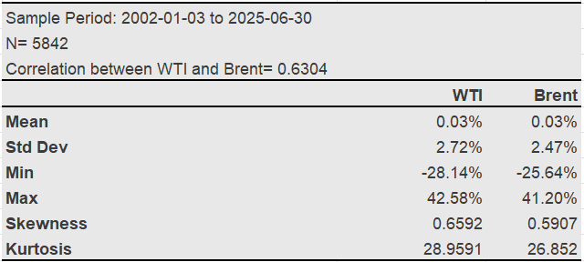
Despite representing different markets, WTI and Brent are strongly correlated with the index of 0.63. This emphasizes the interconnected nature of global oil markets and the spillover effects of shocks across regional markets.
An event dataset was constructed from official press releases and meeting summaries published by the OPEC secretariat, to assess the market impact of OPEC announcements. Each meeting of press release is treated as separate event, and decisions are categorised as into 3 mutually exclusive types: production increases, production cuts and no change in the level of production. The sample covers the period of January 1st, 2002, to May 28th, 2025, as OPEC officially started to document their meetings since 2002. The event dataset consists of 97 OPEC decisions.
Table 2 shows the frequency of each decision over the sample period which records 23 instances of increase, 26 instances of cut and 48 instances of no change decisions. OPEC typically meets on a semi-annual basis during regularly scheduled meetings although, extraordinary meetings can occur as a response to significant geopolitical or market changes. These events are subsequently used as part of a study of events to assess their information content and price impact on the WTI and Brent markets.

Table 2. OPEC Announcements
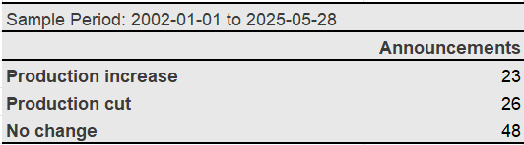

3.2 Event Study Methodology on oil price returns
Event study methodology is broadly applied in financial economics, allowing researchers to isolate the effects of specific events from general market movements.
This methodology discloses and measures the market’s reaction to a specific event by examining abnormal returns around the event date. Abnormal returns are the difference between realised and expected or “normal” returns in the absence of the event (Campbell et. al., 1997). Event window is the time frame in which the expected return is measured. Determining the event window is very crucial. Short event windows, such as [−1, +1] or [−3, +3] days, are widely used. Such short windows are designed to capture immediate market reactions, including any information leakage before or after the official announcement date (Kothari and Warner, 2004).
The estimation of normal returns is a critical step in event studies. Various models can be employed, including the constant mean return model, the market model, or factor models. The market model, which regresses the security's returns on a market index, is frequently preferred due to its ability to control for broader market movements that are unrelated to the specific event (Brown and Warner, 1985). In this study, we employ market model to assess the impact of an OPEC events on oil prices.

3.2.1 Abnormal Returns and Market Model
The calculation of abnormal returns is expressed as follows:
${AR}_{it}= R_{it}-E(R_{it})$
In this equation, ${AR}_{it}$ represents the abnormal returns for oil benchmark $i$ at time $t$. $R_{it}$ is the actual observed returns of an oil index at time $t$. $E(R_{it})$ are the expected returns predicted by the market model.
After calculating daily abnormal returns, average daily abnormal returns are calculated:
$$\overline{{AR}_{t}}= \sum_{t=1}^{n}{\frac{{AR}_{it}}{n}}$$
The market model, based on Capital Asset Pricing Model (CAPM), is specified as follows:
$$R_{it}= α_{i}+β_{i}R_{mt}+ ε_{it} (1)$$
where, $R_{it}$ is the return of a chosen oil index at time $t$ . $R_{mt}$ is the return of the market index. i.e., the S&P 500 daily returns. S&P 500 index is preferred in this study, because equity market is correlated with oil market making this index a great fit for the model. The parameters $α$ and $β$ are estimated in a pre-event estimation window consisting of 120 trading days and ending one day before the event. The expected returns during the event window are then calculated using these estimated parameters, and the difference between the actual and expected returns yields the abnormal returns.
Since, we assume that the expected value of error term $ε_{it}$ is 0, the error term is in fact the abnormal return at $t$ in event time, i.e.,
${AR}_{it}=$ $ε_{it}$

3.2.2 Event Windows and Cumulative Abnormal Returns
In this empirical research, we evaluate multiple symmetric event windows such as [-3, +3], [-5, +5], [-10, +10], and [-30, +30] to assess both immediate and delayed market signals.
The cumulative average abnormal returns (CARs) are calculated as the sum of the average abnormal returns from a day -k to a specific day. Thus, CARs are the sum of abnormal returns over a specified event window. This aggregation helps to summarize the market reaction, which can last for several days, and to summarize the impact of an event in a single indicator. The formula is given below:
$${CAR}_{t}=\sum_{i=-k}^{t}{\overline{{AR}_{t}}}$$
Statistical tests are used to determine whether CARs are statistically significant for multiple events. This indicates whether an event has a significant impact on the market (Kothari and Warner, 2004). In this study, CARs will be calculated for different event windows and tested accordingly.

3.2.3 Hypothesis testing of CARs
In this analysis, we conduct two-factor t-tests for each decision type (cut, increase, no change) and oil benchmark to examine whether the average cumulative abnormal returns are significantly different from zero. Subsequently, we can evaluate whether the null hypothesis that OPEC decisions do not affect crude oil returns is true:
$H_{0} : {CAR}_{T}-{CAR}_{1}=0$,
where $CAR_{T}$ is s the cumulative abnormal return over the full post-event window (e.g., 3, 5, 10, 20) and $CAR_{1}$ is the abnormal return on the first trading day after the announcement. This determines whether the market reaction will be immediate or persist for a certain period. Significance levels are evaluated using standard t-tests. Under the assumption of market efficiency, any abnormal returns observed after an event should quickly converge to zero. This shows that all available information has been fully incorporated into asset prices at the time of the event (t=0) or very shortly thereafter. Significant abnormal returns would instead be interpreted as an incomplete or delayed reaction in the post-event window, indicating market inefficiency.

3.3 GARCH Modelling in Oil Markets
GARCH models are very suitable for capturing dynamics and natural complexity of volatility and returns. Like any other financial time series, oil returns have stylised facts that challenge standard econometric assumptions.
One such assumption is volatility clustering. Significant changes in oil prices are followed by significant changes, while small changes are usually followed by small changes (Cont, 2001). This implies that volatility tends to be clustered and thus is not constant over time. Another assumption is heavy tails. The distribution of oil price volatility has a higher peak around the mean value and fatter tails than a normal distribution (Cont, 2001). Negative shocks are often followed by higher volatility compared to positive shocks (Cont, 2001), a phenomenon known as “volatility asymmetry”. After periods of high volatility, the distribution tends to revert to a long-run average over time. Lastly, for some financial series, the past volatility shocks may continue for extended periods, decaying slowly. Mensi, Hammoudeh, and Yoon (2014) specifically researched the presence of long memory in crude oil returns and volatility in the context of OPEC news and structural breaks.
The Autoregressive Conditional Heteroskedasticity models, introduced by Engle (1982) and later extended to Generalized ARCH (GARCH) models by Bollerslev (1986), have become one of the main methods for modelling and forecasting volatility in financial markets. These models show that return volatility is not constant but depends on past errors and past volatility. Maximum Likelihood Estimation (MLE) is the key approach to estimate GARCH models. It assumes a specific distribution for error term such as Gaussian, and Student's t etc.
To investigate the behaviour of oil returns and volatility in response to OPEC production announcements, we use GARCH models that capture basic stylised facts of financial time series. The models used include the standard GARCH (1,1) model as well as two asymmetric versions, EGARCH and TGARCH/GJR-GARCH, applied to the WTI and Brent daily crude oil return series.
GARCH (1,1) assumes positive and negative shocks of the same size have the same effect on volatility. It does not account for asymmetry, or the leverage effect, where negative shocks tend to increase volatility more than positive ones. The EGARCH (Nelson, 1991) and GJR-GARCH (Glosten, Jagannathan, & Runkle, 1993) models were introduced to account for this issue.

3.3.1 GARCH Models for oil returns
In this context, we extend the traditional GARCH framework by including dummy variables of OPEC decisions in the mean equation, allowing us to directly estimate the impact of production announcements on oil returns.
We created a structured set of dummy variables reflecting OPEC announcements of production cuts, increases and no change in production to assess their impact on oil returns. We use a set of dummy variables that covers the period from two days prior to each announcement to two days after the announcement (i.e., t-2 to t+2) to estimate the full-time impact of OPEC announcements on oil returns. We can identify the immediate impact of the production decision on the day of the announcement using this event window, as well as any anticipatory movements (e.g., information leaks or market expectations) as well as any delayed changes. We capture the dynamic market reaction to OPEC's action over a short horizon by explicitly modelling each day in this time window:
$$\left\{\begin{aligned}d_{cut,t}= 1 if a production cut is announced on day t \\ d_{no change,t}= 1 if a no change is announced on day t \\ { d}_{increase,t}= 1 if a production increase is announced on day t \end{aligned}\right.$$
$$0 otherwise$$
The resulting dummy variables were included as exogenous variables $d_{l,t}$ in the mean equation of the ARX–GARCH (1,1), ARX–EGARCH (1,1), and ARX–TGARCH (1,1) models:
$$r_{t}= μ+ ϕ{r }_{t-1}+\sum_{g=0}^{G}{\sum_{l=3}^{3}{δ_{l}{ d }_{l, t }+ ε_{t}}} (2)$$
$ε_{t}= z_{t} \sqrt{h_{t}}$ , $z_{t}∼N(0,1)$
where:
- ​ $r_{t}$is the oil return at time $t$,
- $r_{t-1}$​ is the lagged return (AR (1) component),
- $d_{l, t}$ denotes dummy variables for three main OPEC decisions (“cut”, “no change”, “increase”) within a ± window of days around event $t$,
- $δ_{l}$​ measures the return impact of OPEC production decisions,
- $ε_{t}$​ is the residual term, with conditional variance $h_{t}$​,
- $z_{t}$ is an i.i.d. error term.
In the above equation, $h_{t}$ is the conditional variance which will be modelled using different GARCH specifications discussed in the followed sections.

3.4 GARCH Models for oil price volatility
Given significant empirical evidence presented in the literature, which indicates that a GARCH (1,1) model adequately captures the stylised facts of volatility of financial time series (Bollerslev, 1986), we employ GARCH (1,1), EGARCH (1,1), TGARCH (1,1) models. Moreover, higher-order models often provide insignificant improvement at the expense of interpretability and overfitting (Chatfield, 2003).
- GARCH (1,1) Model
The most common model is GARCH (1,1) model. It defines the conditional variance at time t and is expressed below:
$h_{t}= ω+αε_{t-1}^{2}+βh_{t-1} \left(3\right)$,
$$ω>0, α≥0, β≥0, α + β < 1$$
where, $ε_{t-1}^{2}$ is a squared residual shock from $t-1$lag obtained from the mean equation. This model captures the volatility clustering in oil prices. GARCH model implies a “volatility spike”, when OPEC announcements result in large price fluctuations.
- Asymmetric Volatility Models
The EGARCH focuses on the logarithm of conditional volatility and ensures that it is strictly positive and includes asymmetry terms. The formula is specified below:
$$\ln\left(h_{t}\right)= ω+ α\left(\left|\frac{ε_{t-1}}{σ_{t-1}}\right|-E\left[\left|\frac{ε_{t-1}}{σ_{t-1}}\right|\right]\right)+ γ\frac{ε_{t-1}}{\sqrt{h_{t-1}}}+β\ln\left(h_{t-1}\right) \left(4\right) ,$$
where, $γ$ is an asymmetry coefficient. A $γ<0$, implies that negative shocks increase volatility more than positive ones.
TGARCH/GJR-GARCH includes dummy variable to differentiate the impact of positive and negative shocks.
$h_{t}= ω+αε_{t-1}^{2}+{γε}_{t-1}^{2}I_{t-1}+βh_{t-1} (5)$ ,
$$ω>0, α≥0, β≥0, α + β < 1$$
$I_{t-1}$ equals 1 if the shock is negative ($ε_{t-1}<0)$ and 0 otherwise. Thus, if $γ$is positive and statistically significant — it implies the presence of leverage effects.
Applying EGARCH or TGARCH models to WTI and Brent price returns can help show whether OPEC decisions affect volatility differently during increases versus decreases in oil production. For example, an unexpected increase in production (higher supply, lower prices) may increase volatility more than a production cut of the same volume (lower supply, higher prices). These models are well suited to detect such differences.
Our methodology to detect volatility in oil returns as a result of OPEC announcements is comprised of two-stage econometric analysis. In the first step, we obtain conditional variance by estimating GARCH models. Maximum likelihood is used to estimate each model assuming normal errors. Model diagnostics (ARCH LM test, Ljung-Box test, Jarque-Bera test) are conducted on standardised residuals to ensure robustness, which is presented in Appendix section (Table 1-a, 1-b, 2-a, 2-b).
The conditional variance of each model, $h_{t}$is extracted and its square root is used as the dependent variable in the second step of the analysis. We employ OLS and quantile regressions to evaluate the effect of OPEC announcements. While OLS provides a benchmark estimate of the average effect primarily serving as a baseline model in this study, quantile regression offers captures potential asymmetry by estimating the effects at different points of the conditional volatility distribution (Koenker & Bassett, 1978).

3.4.1 OLS estimation
The first regression model estimates the average marginal impact of each type of OPEC event on conditional volatility using the ordinary least squares (OLS) method:
$\sqrt{\hat{h_{t}}}= α_{0}+$ $\sum_{l=-g}^{g}{δ_{l}{ d }_{l, t }+ u_{t}} \left(6\right) ,$
where$\sqrt{\hat{h_{t}}}$ is the square root of the estimated conditional variance from GARCH models at time $t$. Since, our focus is on volatility instead of variance, it is important to replace $\hat{h_{t}}$ with its square root to account for conditional standard deviation. ${ d }_{l, t }$ is a set of dummy variables indicating the presence of an OPEC event of type $l$ at time $t$. The parameter $δ_{l}$ records the impact of an event $l$ days before or after day $t$. The summation index $l$ varies from $-g$ to $g$, where g= [-2;2] is chosen to account for both short-term expectations and lagged volatility adjustment effects in a symmetrical 7-day event window around the decision date. The error term $u_{t}$ is assumed to be a white noise.
Additionally, since EGARCH (see eq. 4) models the log of conditional variance, $\hat{h_{t}}$ should be replaced with the exponential of the log variance estimates (e.g., $\hat{h_{t}}=exp⁡(\log{\hat{h_{t}} )}$).

3.4.2 Quantile regression estimation
Koenker and Bassett (1978) developed a method of quantile regression (QR) that allows for a more detailed analysis of the impact of OPEC policy on the volatility distribution in the oil market. Unlike the ordinary least squares method, which only considers the conditional mean, QR estimates the effects at several percenriles (quantiles) of the conditional volatility distribution, including the 25th, 50th (median), and 75th percentiles. Similar to OLS regression, we take the square root of GARCH-estimated conditional variance $\hat{h_{t} }$ and use as dependent variable in quantile regression. The model is specified as below:
$Q_{\hat{h_{t}}}\left(τ\right)= α_{0 }\left(τ\right)+$ $\sum_{l=3}^{3}{δ_{l}{ \left(τ\right) d }_{l, t }+ u_{t}} \left(7\right)$,
where $Q_{\hat{h_{t}}}\left(τ\right)$is the $τ$ -th conditional quantile (e.g., $τ=0.25, 0.5, 0.75$) of the conditional volatility at time $t$. ${ d }_{l, t }$ is a set of dummy variables capturing all three OPEC decisions from two days before to two days after the announcement and $δ_{l}{ \left(τ\right) }_{ }$measures the marginal effect of these decisions at different quantiles of the volatility distribution. This method provides us with a more comprehensive and nuanced understanding of the informational impact of OPEC statements, allowing us to assess whether market reactions to these decisions are different under low, medium, and high volatility conditions.

4. Empirical Findings

4.1 Event study analysis results
In this section, we present results for both WTI and Brent around OPEC’s three production decisions over a ±30-day event window. Figures 1 and 2 display cumulative abnormal returns of WTI and Brent for three OPEC decisions from event day −30 to event day 30.
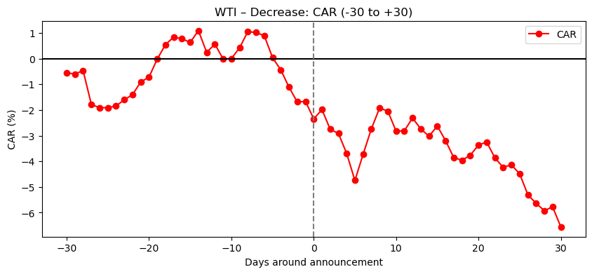
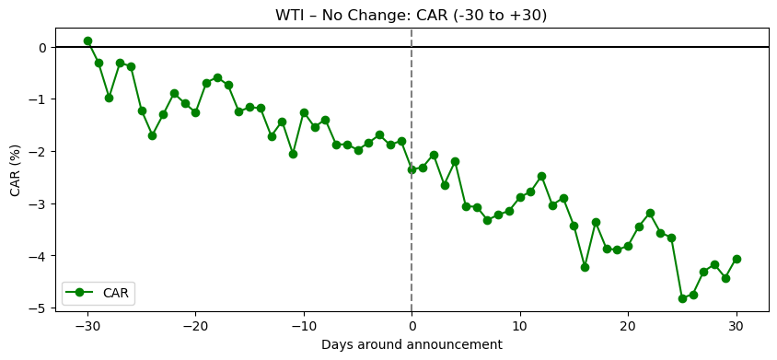
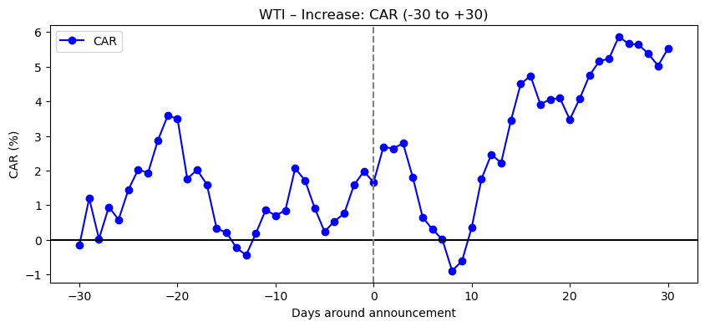
Figure 1. Cumulative abnormal returns of WTI for three OPEC decisions from event day −30 to event day 30

Figure 2. Cumulative abnormal returns of Brent for three OPEC decisions from event day −30 to event day 30
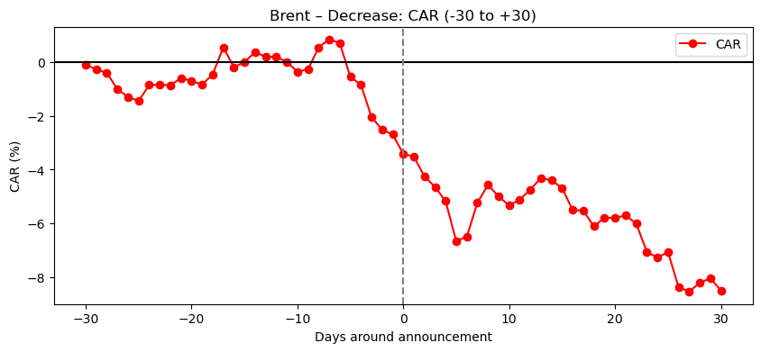
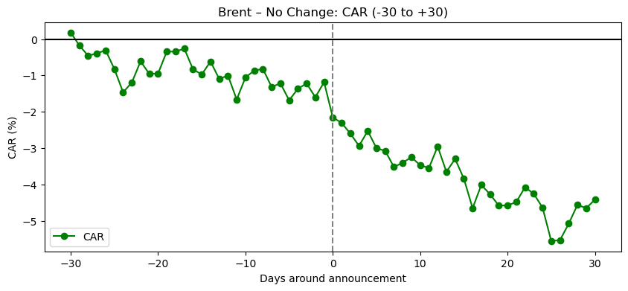
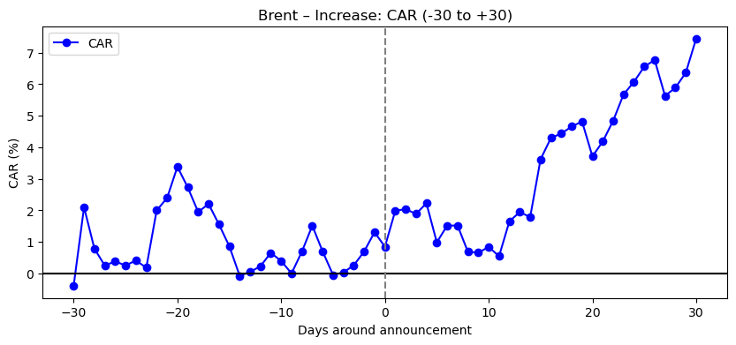

Furthermore, Tables 3 and 4 show the results reveal the significance of CARs across several pre- and post-event windows (±3, 5, 10, 20, and 30 days) for both WTI and Brent. The timing of market responses, which often occur more pronounced after the announcement, is consistent with a semi-strong form of market efficiency that incorporates public information quickly, but not necessarily instantly (Fama, 1991). These results further illustrate the applicability of event study methods in commodity market research and highlight the complex interplay between investor sentiment, interpretation of market information, and policy decisions in oil prices.

Table 3. CAR differences and absolute t-statistics and p-values for WTI returns
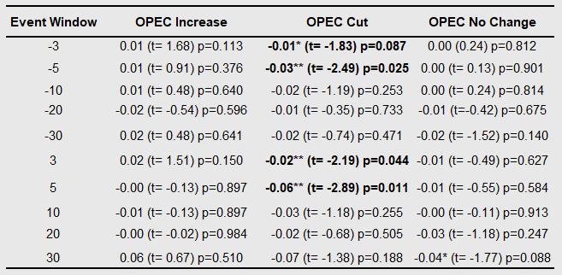
Note: Coefficients marked with ***, **, and * are statistically significant at the 1%, 5%, and 10% levels, respectively.

Table 4. CAR differences and absolute t-statistics and p-values for Brent returns
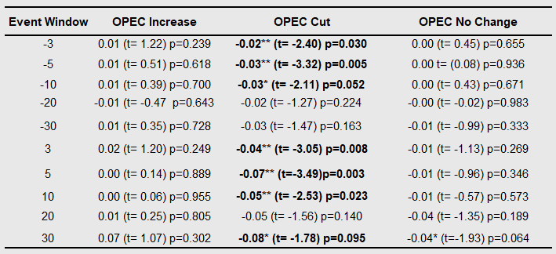
Note: Coefficients marked with ***, **, and * are statistically significant at the 1%, 5%, and 10% levels, respectively.

Findings reveal the significant asymmetry in market reactions based on the type of decision for both series, which is supported by earlier studies (Demirer and Kutan, 2010; Loutia et al., 2016).
For production cuts, CARs exhibit downward sloping trend and experience consistent decline for both oil benchmarks. Given that production cuts should reduce supply and maintain prices, these results are counterintuitive. One of the reasons for this misalignment with core theory could be market participants’ perception. The prior studies show that these announcements are often interpreted as indicators of decreased demand or economic instability (Bina and Vo, 2007; Loutia et al., 2016). Since compliance among members of the organization is often low and internal cohesion is weak, the market may be cautious about OPEC's statements on production cuts (Colgan, 2014). In our vision, production cuts are perceived more as a reaction to a deteriorating economic condition than as a proactive stabilisation strategy during periods of increased market uncertainty. There is some evidence that markets begin to react in advance for production cut decisions in the days leading up to OPEC for both oil series. In the three and five days leading up to the decision, WTI returns are significantly negative. (CAR-3 = -0.01, p = 0.087; CAR-5 = -0.03, p = 0.025). The dynamics of Brent crude oil prices demonstrate a more pronounced pattern than WTI crude oil prices: OPEC announcements of production cuts have a significant impact on Brent returns as early as ten days before the event (CAR-10 = -0.03, p = 0.052). This could be due to its world benchmark status, which makes the benchmark more sensitive to global shocks and expectations (Loutia et al., 2016). Longer horizons prior to the OPEC meeting date (e.g., 20- and 30-days prior) do not exhibit any significant impact for both oil returns. Given the timing and tone of OPEC's official meetings, this pre-event effect increases the possibility that traders are speculating or that information leakage is present in the market. These results are consistent with Schmidbauer and Rösch (2012). They also provide evidence of volatility changes prior to announcements, demonstrating that OPEC news affects market expectations before official decisions are published. Some studies shows that investor sentiment and geopolitical signals can influence market behaviour ahead of OPEC meetings. For example, Gabbori et al. (2021) note a herding effect on the Saudi stock market during periods of high uncertainty surrounding OPEC meetings. Although this study does not focus specifically on oil markets, its findings may be applicable to them due to the strong correlation between equity and oil markets.
Post-announcement period results show a more significant and persistent price adjustment. In the days following announcements of production cuts, WTI shows a clear decline, with returns turning significantly negative from three to five days after the event. Brent reacts even more sharply: the negative impact is not only greater in magnitude but also persists for ten days after the announcement. These findings again support those of Loutia et al. (2016) and Schmidbauer & Rösch (2012), which show that announcements of production cuts often induce stronger market reactions, especially if they are interpreted as signs of deteriorating macroeconomic conditions or lower demand rather than simply supply adjustments.
In the case of production increases, CARs display upward trend for both oil benchmarks following the announcement date. These findings reflect the market’s delayed upward adjustment to OPEC’s production increase announcements, particularly evident in the second half of the post-event window. It is worth pointing out that, the interpretation of such announcements as positive demand signals, rather than negative supply shocks also do not align with classic supply-demand theory, which states that an increase in output yields price reductions. It seems plausible that market participants might consider the expected changes in demand, sparse production capacity and geopolitical factors which has a significant impact on market expectations after the announcement. For pre- and post-event effect of production increase, CARs are not statistically significant for both WTI and Brent, implying that OPEC announcements do not have any impact on oil returns. This pattern in the market behaviour corresponds to “cheating hypothesis” by OPEC members. According to this hypothesis, OPEC members do not implement the announced production quota increases, which diminishes their informational value (Smith, 2005; Colgan, 2014). Moreover, another earlier study (Demirer & Kutan, 2010) pinpoints that markets tend to adapt more strongly to unexpected or demand-driven signals than to anticipated supply increases.
In case of no-change decisions, both WTI and Brent show comparatively flat to slightly negative CARs, which suggests that markets may perceive these announcements as uninformative or fully priced in. For pre- and post-event effect of no change decisions, CARs are not statistically significant for both WTI and Brent. These findings attribute earlier studies (Bina & Vo, 2007; Lin & Tamvakis, 2010; Demirer & Kutan, 2010), who report that the maintaining the level of quota is an anticipated decision and therefore is a limited new information for market participants.

4.2 GARCH models’ results on oil returns
Before estimating the GARCH models, we performed standard diagnostics to assess the characteristics of the oil return series and confirm the accuracy of the AR fit. Previous studies, such as Narayan and Narayan (2007), Yıldırım (2017), also recommend using AR (1) to identify short-term dependencies in oil returns.
These diagnostics, described in detail in the Appendix section (Table 2-a and 2-b), include tests for autocorrelation, stationarity, and model fit. Given these findings, the AR (1) model is a reasonable choice that accurately reflects the serial dependence of the return series without overfitting. It provides a concise and understandable structure for forecasting expected returns before events occur.
Tables 5 and 6 summarise the estimation results of the AR (1)-GARCH models (i.e., GARCH, EGARCH and TGARCH) applied to WTI and Brent oil returns. The three models are employed to evaluate the impact of production cuts, increases, and no change decisions over a five-day window (t−2 to t+2) around the announcement day (t). The tables show the estimated coefficients for the mean equation of each model together with t-statistics and p-values, to assess the statistical significance of each variable. Key dummy variables identify the timing and direction of volatility reactions, including indicators for each type of decision with specific time lags (e.g., $d_{no change, t-2}$)). Significant coefficients indicate that the oil returns during this period were subject to a measurable influence from related events.
To assess the model's fit to the parameters, we also report the AIC and BIC values. We can determine which model specification best reflects the data dynamics without overfitting by looking at the lower AIC and BIC values, which indicate a better balance between fit quality and parsimony.
Table 5. Estimation results of AR (1) model for expectation of WTI returns
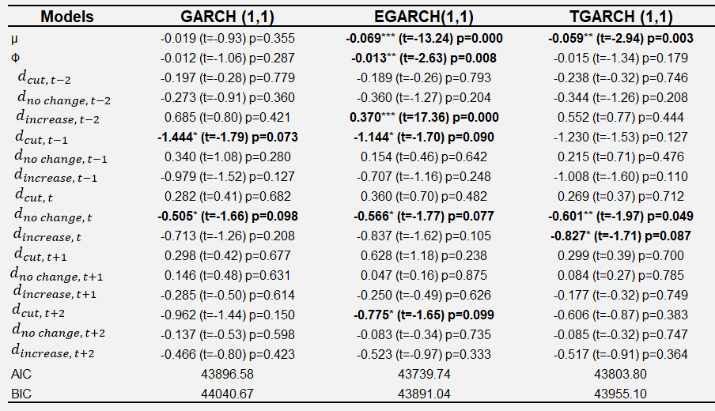
Note: Coefficients marked with ***, **, and * are statistically significant at the 1%, 5%, and 10% levels, respectively.
The intercept $μ$ in GARCH is small and statistically insignificant for both WTI and Brent returns but becomes negative and significant in EGARCH and TGARCH. This suggests that average returns tend to decline when asymmetry is considered, which is consistent with Schmidbauer & Rösch (2012), who reported that ignoring asymmetry underestimates the actual impact of OPEC's actions.
The autoregressive term 𝜙, is consistently negative and statistically significant for WTI returns in EGARCH and TGARCH models, whereas it is highly significant and positive across all models for Brent returns. This indicates that there is a significant negative or positive short-term persistence in oil returns depending on oil benchmark, in other words, historical returns can be used to predict current returns. This aligns with earlier studies such as Mensi et al. (2004) and Aloui et al. (2013) who report structural differences in market depth, information flow, and liquidity in oil markets.
The effects of OPEC announcements differ depending on the type of decision and the announcement date. WTI shows a moderately significant decline on the day before (p = 0.09) and two days after (p = 0.099) the announcement, indicating that it responds most clearly to production cuts in EGARCH and GARCH models. This indicates that the market reaction continues after the announcement day, which is consistent with other studies showing an extended period of market adjustment to OPEC news (Demirer & Kutan, 2010; Loutia et al., 2016; Schmidbauer & Rösch, 2012). Brent's pattern differs – returns in EGARCH rise sharply on the day following the cut (p = 0.048). Production cut decisions may be interpreted as optimistic signals about supply from Brent, the global benchmark, especially if traders expect them to be implemented by OPEC. This suggests that Brent market usually responds more to anticipated supply constraints following a cut.
WTI shows a very significant positive jump two days before the production increase decision (p = 0.000, EGARCH), indicating that markets often anticipate price increases before the official meeting—possibly as a result of information leaks or speculative positions. For Brent, the situation is the opposite: TGARCH shows a slight decline the day before (p = 0.098), while EGARCH records another decline two days after the announcement (p = 0.091). These conclusions imply that once the decision is confirmed, the eventual supply implication could lead to a decline in prices, even if the increase decision is anticipated.
For no-change decisions, WTI reports marginally significant negative returns on the announcement date for all models (GARCH: p = 0.098; EGARCH: p = 0.077; TGARCH: p = 0.049). This can suggest dissatisfaction when markets expected an action from OPEC, perhaps a production cut, but production was maintained on the same level. The response of Brent is statistically insignificant, indicating that decisions not to change production quotas are generally neutral for the global benchmark. Mensi et al. (2014) report a similar pattern of more pronounced reactions for WTI rather than Brent.
Comparing benchmarks, WTI appears more sensitive to pre-announcement dynamics, as demonstrated by significant reactions ahead of production increases, possibly due to faster information dissemination or speculative positioning. Brent, on the other hand, reacts to production cut more gradually, with noticeable changes appearing in the days after the event. This is probably due to Brent's broader presence in the global market and the slower absorption of new information by a more diverse group of market participants.
However, Brent is informationally efficient, according to a few empirical studies (e.g., Charles and Darné, 2009), whereas WTI does not appear to have this quality, which has been more pronounced in recent years due to the pipeline issue in the United States' Midwest.
While the GARCH model identifies immediate, often statistically significant, post-announcement reactions, the event study results suggest that longer-term cumulative returns may trend in an opposing direction. This contrast may reflect the market’s shifting sentiment from an initial reaction to a more measured assessment of OPEC's decision implications.

Table 6. Estimation results of AR (1) model for expectation of Brent returns
Note: Coefficients marked with ***, **, and * are statistically significant at the 1%, 5%, and 10% levels, respectively.
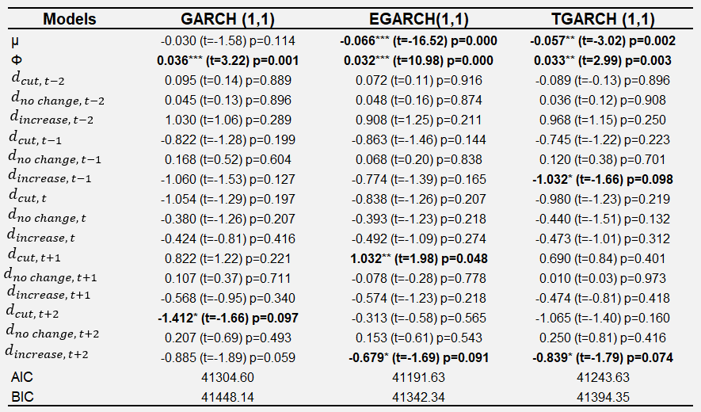
EGARCH (1,1) consistently provides the best fit according to AIC/BIC, indicating that returns asymmetry should be considered when modelling oil price responses to OPEC decisions.

4.3 GARCH models’ results on oil price volatility

4.3.1 Conditional variance estimates
Figure 3. Conditional variance from GARCH (1,1)
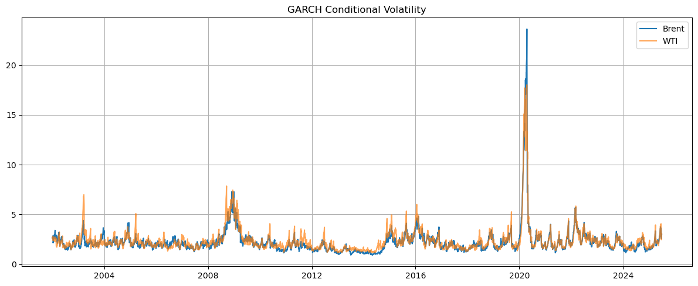

Figure 4. Conditional variance series from EGARCH (1,1)
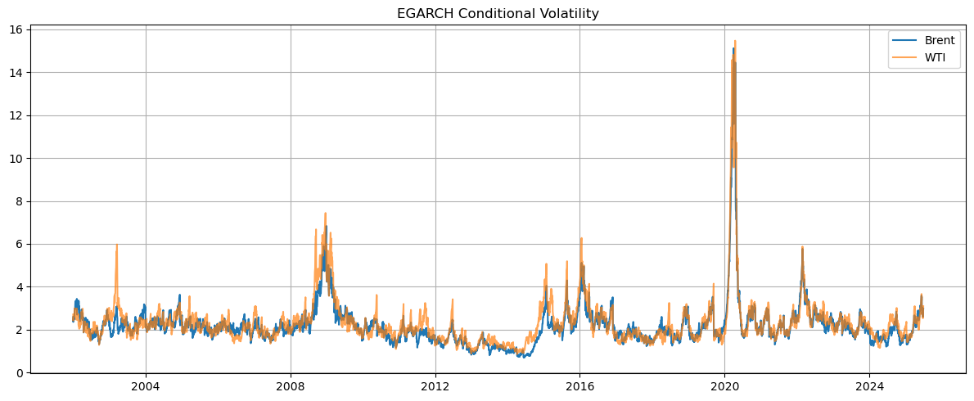

Figure 5. Conditional variance series from TGARCH (1,1)
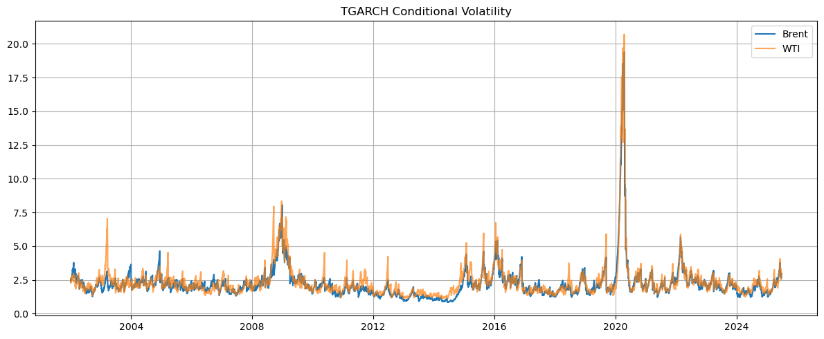
To capture the dynamics of conditional volatility of oil returns, GARCH (1,1), EGARCH (1,1), and TGARCH (1,1) models were estimated separately for Brent and WTI crude oil benchmarks. Two repeated characteristics of oil markets: volatility clustering and sharp jumps around significant shocks, included in the literature review are shown using calculated conditional variances, which are presented in Figures 3–5. The 2008 financial crisis and the COVID-19 pandemic-induced collapse in demand in 2020 are two examples of significant and ongoing volatility that are not directly related to OPEC decisions but are nonetheless subject to the same dynamics of uncertainty and information adjustment.
The GARCH models’ specifications used in this study are generally adequate, as confirmed by diagnostic tests depicted in the Appendix section (Table 3-a and 3-b). The residuals for Brent and WTI do not reveal any noticeable ARCH or autocorrelation effects. Although the Jarque-Bera test rejects normality, this was expected given the well-known heavy tails in oil return distributions.
Table 7. Parameters of estimated variance of WTI
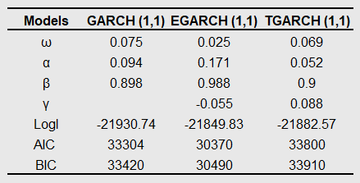
Table 8. Parameters of estimated variance of Brent
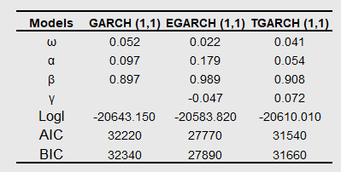
Based on Tables 7 and 8 all models satisfy the fundamental constraints required for model validity for both crude oil benchmarks. The parameters 𝜔 > 0, 𝛼 ≥ 0, and 𝛽 ≥ 0 were satisfied for the standard GARCH (1,1) model, and the criterion 𝛼 + 𝛽 < 1, guaranteeing stationarity of covariance and finite unconditional variance, was not violated. Similarly, for the TGARCH and EGARCH models, no signs of explosive variation dynamics were found, and the corresponding non-negativity and sign requirements were met. These results allow us to conclude that the estimated models are theoretically valid and demonstrate good statistical behaviour.
In addition, for both types of oil benchmarks, EGARCH allows for leverage effects through a negative γ parameter (Brent: -0.047; WTI: -0.055), indicating that negative shocks increase volatility to a greater extent than positive shocks of the same magnitude. Asymmetry with positive γ values is also captured by TGARCH, but EGARCH offers a more adaptable and statistically superior structure.
Overall, the results show that again EGARCH (1,1) is the best model for use with WTI and Brent oil prices volatility. According to earlier studies, asymmetric GARCH models are relevant for energy markets (Kroner & Ng, 1998; Malik & Ewing, 2009).

4.3.2 OLS regression results
The estimated conditional variance obtained using the GARCH (1,1), EGARCH (1,1), and TGARCH (1,1) models were square root transformed and used as dependent variables in ordinary least squares (OLS) regression (see eq. 6) to assess the impact of OPEC policy decisions on oil market volatility.
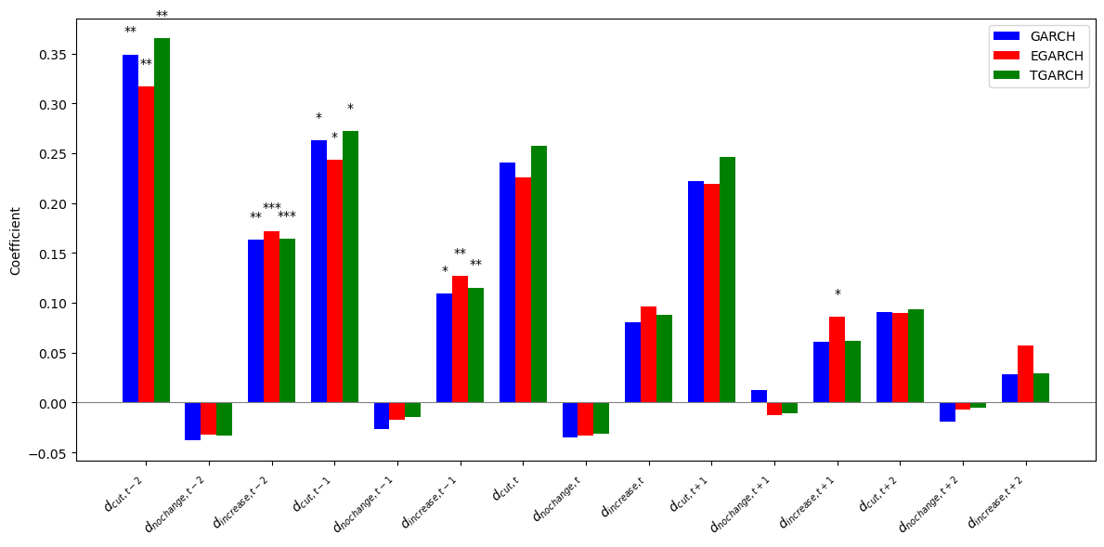
Figure 6. OLS regression results for WTI’s conditional volatility
Note: Bars show estimated coefficients for GARCH (1,1), EGARCH (1,1), and TGARCH (1,1) models. Coefficients marked with ***, **, and * are statistically significant at the 1%, 5%, and 10% levels, respectively.
*
Figures 6 and 7 demonstrate the OLS regression analysis for WTI and Brent conditional volatility via bar chart. The detailed table indicating all coefficients, t-statistics and p-values across all models are depicted in Appendix (Table 4-a and 4-b). The most notable influence on both WTI and Brent is the increase in volatility two days before the announcement. For both oil benchmarks, this effect is statistically significant in the case of production increase across all models, while a production cut shows a slightly smaller but still significant increase in volatility in the same interval prior to the announcement. Similarly, there is a small and significant effect in volatility with Brent showing more pronounced reaction one day prior to and on the day of announcements to both increase and cut. As discussed in case of oil returns, these results again confirm that the market is responding to expectations ahead of the official decisions, most likely through information leakage or speculative positions. On the other hand, apart from a few insignificant effects, such as the detection of an EGARCH response to a production increase one day after the announcement for both oil benchmarks, statistically significant changes in volatility on the announcement day and in the post-announcement period are practically not observed. Overall, the result of the study suggests that most of the volatility appears to be the result of expectations rather than reactions. When expecting changes in production volumes, market participants appear to take positions ahead of official announcements. Horan et al. (2004) confirms this anticipated effect of elevated volatility in the days leading up to OPEC meetings and decreasing after them.
*

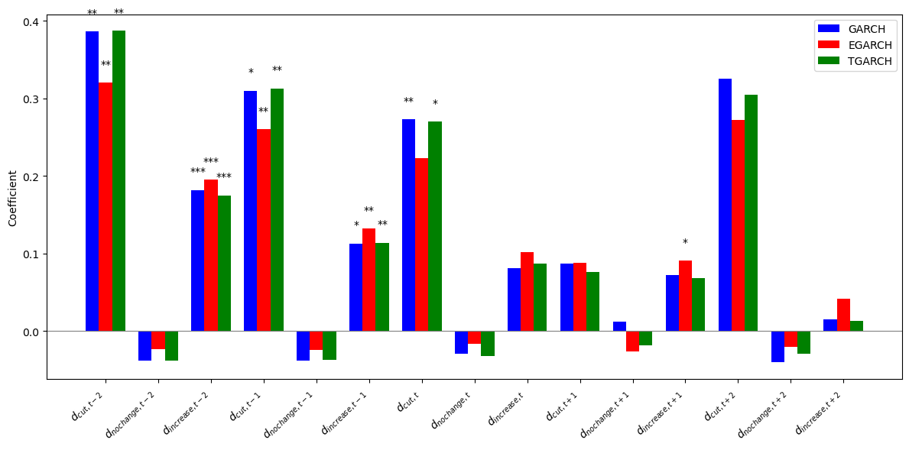
Figure 7. OLS regression results for Brent’s conditional volatility

*
Note: Bars show estimated coefficients for GARCH (1,1), EGARCH (1,1), and TGARCH (1,1) models. Coefficients marked with ***, **, and * are statistically significant at the 1%, 5%, and 10% levels, respectively.

4.3.3 Quantile regression results
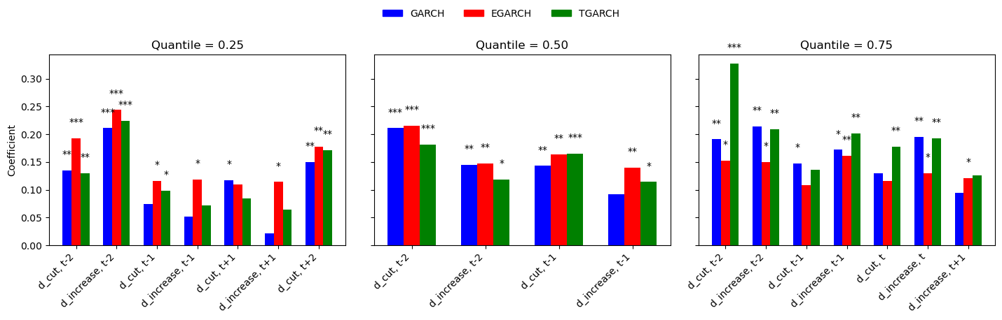
Note: Bars show estimated coefficients from quantile regressions at the 25th, 50th, and 75th conditional volatility quantiles. Coefficients marked with ***, **, and * are statistically significant at the 1%, 5%, and 10% levels, respectively.
Figure 8. 25th, 50th, and 75th quantile regression results on WTI’s conditional volatility
Figures 8 and 9 demonstrate quantile regressions (see eq. 7) estimated based on conditional volatilities (square root of conditional variance) obtained from GARCH (1,1), EGARCH (1,1), and TGARCH (1,1) models to examine differences in the impact of OPEC decisions depending on the conditional volatility distribution. Although Section 2.3 and the study of Gupta et al. (2017) raise the issue that OPEC policy may have uneven effects under different volatility regimes, meanwhile OLS only considers average effects. Quantile regression allows us to examine this by estimating the effects at the 25th, 50th, and 75th percentiles of the conditional volatility distribution. OLS is used to perform regressions on each quantile subsample, and all reported results are only statistically significant at the 10% or higher. The detailed table indicating all coefficients, t-statistics and p-values across all models are depicted in Appendix (Table 5-a and 5-b).
All states of volatility have an anticipatory effect on WTI, although they are more noticeable when the market is already in a state of high volatility. Both increases and decreases in production quotas have a significant impact on the 25th, 50th and 75th percentiles two days prior to the meeting, even in relatively calm conditions across all models. These results are consistent with earlier evidence, which claim that oil markets react immediately to credible signals of future changes in supply, especially when OPEC or other strategic players are involved (Horan et al., 2004; Schmidbauer & Rösch, 2012; Mensi et al., 2014; Loutia et al., 2016). The response to volatility becomes less pronounced at the 50th percentile, which implies medium volatility market state. However, the magnitude of the reaction to the cuts two days before the meeting increases significantly in high volatility market states, which is consistent with the findings of Ederington and Lee (1996). They argued that periods of elevated uncertainty, announcement effects are amplified. Cut and increase decisions continue to intensify volatility on the day of the announcement and post-announcement period in low and high volatility regimes, indicating that uncertainty may persist after the decision is made. In accordance with the uncertainty following the announcement and the dynamics of information absorption, this implies the existence of delayed volatility reactions.
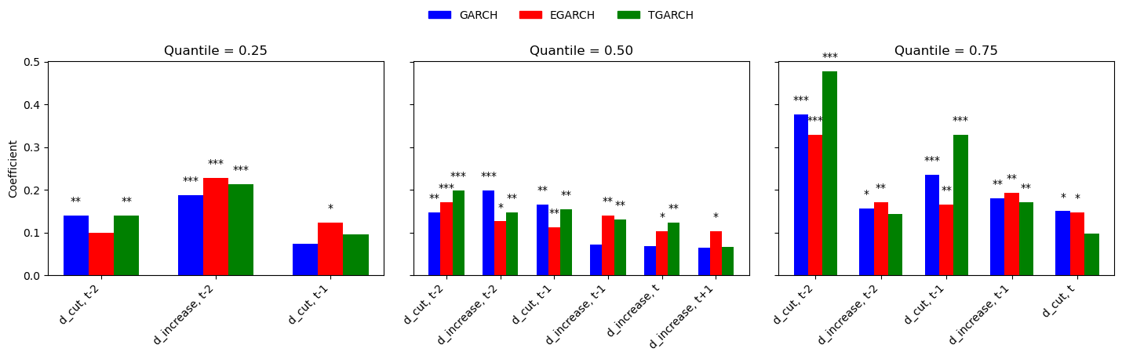
Figure 9. 5th, 50th, and 75th quantile regression bar chart results on Brent’s conditional volatility
Note: Bars show estimated coefficients from quantile regressions at the 25th, 50th, and 75th conditional volatility quantiles. Coefficients marked with ***, **, and * are statistically significant at the 1%, 5%, and 10% levels, respectively.
Brent demonstrates higher sensitivity, showing a noticeable effect of pre-announcements not only during periods of high volatility, but also during periods of low and medium volatility. However, both increases and decreases in production quotas declared two days prior to the announcement are associated with a statistically significant increase in volatility in calm state of markets across all models. These results are consistent with the findings of Pierru et al. (2018), which show that even in stable conditions, markets remain extremely sensitive to supply expectations, as spare production capacity plays a crucial role as a shock absorber.

For the 50th quantile, the median volatility, the impact is the strongest and most persistent. Both cuts and increases two days prior to the meeting remain influential, and within asymmetric EGARCH model, their effects often remain noticeable on the day of the announcement. The results show that although both Brent and WTI react significantly to OPEC decisions, Brent demonstrates slightly higher and consistent responsiveness in the early stages, especially during periods of low and medium volatility. As the same case with oil returns, Brent crude oil is more widely used as a benchmark for determining global prices, making the benchmark more vulnerable to changes in global supply signals (Nelson, 2025). On the other hand, WTI is exhibiting volatility that is slightly more concentrated at the tails of the distribution, indicating that the US benchmark is reacting more strongly to elevated market uncertainty.
Quantile regression results suggest that the impact of OPEC announcements varies across states in both markets, with a stronger impact observed in quantiles with higher volatility. Despite some coincidence in timing, the OLS results appear to ignore the asymmetry of the market response and underestimate its importance. These results highlight the value of using quantile regression to identify heterogeneous volatility responses in different market regimes and confirm the findings of earlier studies that emphasized the need to model oil market volatility using distribution-sensitive approaches. One of these studies is shown by Reboredo (2016), who reports the relationship between oil and stock returns varies depending on return quantiles.

5. Conclusion
The purpose of this study was to examine the impact of OPEC's three main production decisions—cuts, increases, or announcements of no change—on the volatility and prices of crude oil. The market reaction was captured using GARCH models and event study methodology across different time windows, under different market expectations and volatility regimes. The data has covered two key global benchmarks: WTI and Brent for over 20 years period, providing a solid foundation for reliable empirical observations.
In the case of oil returns, using the event study methodology, significant asymmetries in market reactions were identified depending on the type of OPEC decision. The production cuts were associated with a persistently negative CARs, especially for Brent crude, indicating that markets view these decisions as signals of future declining demand or economic uncertainty rather than supportive supply cuts. On the other hand, the production increase led to slightly positive and delayed CAR indicators, which points to a more complex market situation where the production increase is often seen as a sign of higher demand rather than an expansion of supply leading to lower prices. Maintaining the current level of production decisions resulted in weak or statistically insignificant CARs, indicating that such results are typically expected or do not provide new information to the market.
These conclusions were confirmed by a pre-event analysis, which revealed early market moves in anticipation of the production cut decision. In the case of Brent, statistically significant abnormal returns prior to the announcement date indicate speculative activity or information leakage. The absence of comparable anticipatory reactions to decisions to increase production or no change decisions highlights limited surprise these events contain, confirming the view that only demand-related or unexpected announcements cause significant adjustments prior to the event. Another reason could be “cheating hypothesis”, in which OPEC members do not implement the announced production quota increases, which reduces their informational content.
The AR (1) - GARCH results provide a different but complementary perspective. GARCH models detect short-term fluctuations in returns directly during the announcement period, while event studies record the direction and duration of the market reaction over time. These models demonstrate that fluctuations in returns depend not only on specific events, but also on benchmarks. For example, WTI returns were more sensitive to production increase announcements, with significant responses occurring even before the event day, indicating stronger anticipatory pricing behaviour. On the other hand, Brent demonstrated a more stable post-event reaction, especially as a result of production cut, which emphasized its position as a global benchmark and, as we believe, a slower assimilation of information by a wider range of market participants.
It is important to note that GARCH models indicate that Brent may initially react negatively, even though event study shows that increased production will ultimately lead to slightly positive CARs. This divergence suggests that initial market sentiment, which is often pessimistic or uncertain, can change over time as new information becomes available or the implications of policy decisions become clearer. Although GARCH models reveal statistically significant effects in narrower windows, both approaches align in detecting negative reactions as a follow-up to OPEC's production decline decision. A comparative analysis also reveals a temporary discrepancy: GARCH models capture short-term but statistically accurate fluctuations in oil returns, while event study highlights persistent patterns that may reflect long-term adjustments in market sentiment. This discrepancy shows that although markets may initially react abruptly, the cumulative effect of these decisions is determined by subsequent events and a constant reassessment of the situation.
In the case of oil prices volatility, the analysis was extended to both OLS and quantile regression, allowing for a deeper investigation of how these reactions vary depending on the volatility distribution. The results of the OLS model show that there is a statistically significant effect of predicting oil market volatility in the days preceding OPEC announcements, especially two days before the announcement of both production cut and increase decisions. In all three models, this trend is consistently observed for both Brent and WTI, indicating that traders are actively repositioning ahead of expected policy changes. These findings support the assumption that expectations, rather than announcements themselves, are the major cause of volatility. Given its wider global exposure, Brent also reacts on the day of the announcement, particularly to production cuts, whereas WTI's impact on volatility tends to be recorded peaking before the announcement. This timing difference highlights Brent's heightened sensitivity to global supply issues and geopolitical factors. OLS method does reflect average conditional shifts in volatility; however, it does not adequately account for the fact that increases and decreases in production have different effects on markets depending on the volatility regime.
It is important to note that this gap is addressed by quantile regression, which show that the impact of OPEC announcements varies depending on the volatility regime. Quantile regression results somewhat support those of OLS with some disparities. During periods of low volatility (25th percentile), both WTI and Brent are already showing a statistically significant increase in implied volatility in anticipation of policy changes. This suggests that even in stable market conditions, OPEC's decision alone can disrupt expectations and pricing. This implies that OPEC's potential decision could change expectations and pricing even in stability periods of markets. The reaction to OPEC's statements, especially in case of production cuts, intensifies as market uncertainty increases, which may be due to an immediate response from market participants and more noise in the market.
The decisions of both reductions and increases in production volumes continue to have a strong and statistically significant impact on the 50th quantile, which represents average volatility conditions. Regardless of the volatility regime, market participants consistently interpret OPEC meetings as risky events, as evidenced by the fact that volatility spikes can be observed both during periods of high stress and during periods of relative stability. This suggests that even in situations where markets appear calm, risk managers and institutional traders should activate hedging methods ahead of OPEC announcements.
During periods of high volatility (75th quantile), the impact of production cuts is particularly pronounced. Two days prior to the announcement, there was a noticeable and statistically significant spike in volatility for both Brent and WTI. Interestingly, especially in the case of Brent, that the volatility response to increased production in this quantile is slightly less consistent. This may be due to the market's more complex interpretation of the expansion in supply, which could indicate both anticipated economic growth and a possible oversupply in the market. The asymmetry in volatility response—stronger for cuts than increases—reinforces the notion that production reductions are perceived as more informative, perhaps due to their association with weak demand or geopolitical instability.
For further studies, several extensions can be considered. With additional time and resources, nonlinear models can be employed for the analysis to capture potential asymmetries and regime-dependent dynamics in oil price volatility. Another option would be to use high-frequency intraday data, which provides a more detailed picture of short-term market movements and volatility clustering around OPEC announcements, although it is less readily available than daily or weekly series. Moreover, it may be possible to accurately determine the role of OPEC's policy decisions by expanding the empirical specification to include relevant control variables such as inventory levels, macroeconomic indicators, or geopolitical risk indices. Finally, future research could focus on the role of OPEC+, whose cooperation with non-OPEC producers since 2016 has given new leverage to its influence on global oil markets.
For market participants involved in energy trading, risk management, and investment strategies, the results provide both theoretical knowledge and practical recommendations. First, traders, especially those involved in options pricing, volatility arbitrage, and calendar spreads, benefit from the predictable volatility patterns that follow OPEC meetings. Secondly, judging by the differences in the reactions of both benchmark indices, WTI and Brent should not be considered ideal substitutes in portfolio or hedging models. The heavy-tailed dynamics of WTI makes it more sensitive to sharp market fluctuations and speculative positions, while Brent's faster and more internationally focused responsiveness allows it to react more quickly to geopolitical signals.
Finally, all models show spikes in volatility prior to the announcement, indicating the significance of market expectations and possible information leakage. The results of the study confirm the feasibility of early positioning or use of volatility-sensitive products, such as straddles or volatility swaps, for companies exposed to oil price risk. According to the study, market signals and communication strategies can significantly influence volatility even before an official decision is made, which is important information for OPEC and regulatory authorities. Thus, monitoring public debate surrounding political meetings becomes just as important as the policy itself.
In conclusion, this study shows that OPEC decisions serve as triggers for short-term volatility and fluctuations of returns in the oil market, mainly due to asymmetric market reactions and speculative trading. These factors have serious implications for risk management, asset pricing, and the development of trading strategies in energy markets, and are evident under various volatility regimes and at different benchmark oil prices.

6. References
- Adelman, M.A., 1995. The Genie Out of the Bottle: World Oil Since 1970. Cambridge, MA: MIT Press, pp.141–144. DOI:10.2307/3116891
- Almutairi, H., Pierru, A., and Smith, J.L., 2023. Managing the oil market under misinformation: A reasonable quest? Journal of Commodity Markets. 34, 100403, ISSN 2405-8513. https://doi.org/10.1016/j.jcomm.2024.100403
- Aloui, I., Ben Aïssa, M.S. & Nguyen, D.K., 2013. Conditional dependence structure between oil prices and exchange rates: A copula-GARCH approach. Journal of International Money and Finance. 32, pp.719–738. https://doi.org/10.1016/j.jimonfin.2012.06.006
- Baillie, R.T., Bollerslev, T. and Mikkelsen, H.O., 1996. Fractionally integrated generalized autoregressive conditional heteroskedasticity. Journal of Econometrics. 74(1), pp. 3–30. http://dx.doi.org/10.1016/S0304-4076(95)01749-6
- Baumeister, C. and Peersman, G., 2013. Time-varying effects of oil supply shocks on the US economy. American Economic Journal: Macroeconomics. 5(4), pp.1–28. https://doi.org/10.1257/mac.5.4.1
- Bina, C., Vo, M. (2007). OPEC in the epoch of globalization: An event study of oil prices, Global Economy Journal. 7(1), pp. 1-52. https://doi.org/10.2202/1524-5861.123
- Bollerslev, T., 1986. Generalized autoregressive conditional heteroskedasticity. Journal of Econometrics. 31(3), pp.307–327. https://doi.org/10.1016/0304-4076(86)90063-1
- Brown, S.J. and Warner, J.B., 1985. Using daily stock returns: The case of event studies. Journal of Financial Economics. 14(1), pp. 3–31. https://doi.org/10.1016/0304-405X(85)90042-X
- Campbell, J.Y., Lo, A.W. and MacKinlay, A.C., 1997. The Econometrics of Financial Markets. Princeton, NJ: Princeton University Press, pp.140–181. https://doi.org/10.2307/j.ctt7skm5
- Charles, A., Darné, O., 2009. The efficiency of the crude oil markets: Evidence from variance ratio tests. Energy Policy, 37(11), pp. 4267–4272. DOI: 10.1016/j.enpol.2009.05.026
- Chatfield, C., 2003. The Analysis of Time Series: An Introduction, Sixth Edition (6th ed.). Chapman and Hall/CRC. pp. 1-352. https://doi.org/10.4324/9780203491683
- Colgan, J. D., 2014. The Emperor Has No Clothes: The Limits of OPEC in the Global Oil Market. International Organization. 68(3), pp. 599–632. http://www.jstor.org/stable/43282120
- Cont, R., 2001. Empirical properties of asset returns: stylized facts and statistical issues. Quantitative Finance. 1(2), pp.223–236. http://dx.doi.org/10.1080/713665670
- Demirer, R., Kutan, A.M., 2010. The behavior of crude oil spot and futures prices around OPEC and SPR announcements: An event study perspective. Energy Economics. 32(6), pp.1467–1476. https://doi.org/10.1016/j.eneco.2010.06.006
- Derbali, A., Wu, S., Jamel, L., 2020. OPEC news and predictability of energy futures returns and volatility: Evidence from a conditional quantile regression. Journal of Economics, Finance and Administrative Science. 25(50), pp. 239–259. https://doi.org/10.1108/JEFAS-05-2019-0063
- Ederington, L.H. & Lee, J.H., 1996. The creation and resolution of market uncertainty: The impact of information releases on implied volatility. Journal of Financial and Quantitative Analysis. 31(4), pp. 513–539. https://doi.org/10.2307/2331358
- Engle, R.F., 1982. Autoregressive conditional heteroskedasticity with estimates of the variance of UK inflation. Econometrica. 50(4), pp.987–1007. https://doi.org/10.2307/1912773
- Fama, E. F., 1991. Efficient Capital Markets: II. Journal of Finance. 46(5), pp. 1575–1617. https://doi.org/10.2307/2328565
- Fattouh, B., 2011. An anatomy of the crude oil pricing system. WPM 40. Oxford: Oxford Institute for Energy Studies. http://ora.ox.ac.uk/objects/uuid:8b957970-239c-4a4f-9cbe-21830381de16
- Fattouh, B., Kilian, L., and Mahadeva, L., 2013. The role of speculation in oil markets: What have we learned so far? The Energy Journal. 34(3), pp.7–33. https://doi.org/10.5547/01956574.34.3.2
- Gabbori, D., Awartani, B., Maghyereh, A., & Virk, N., 2021. OPEC meetings, oil market volatility and herding behaviour in the Saudi Arabia stock market, International Journal of Finance & Economics. 26(1), pp. 870-888. Wiley: Available at: 10.1002/ijfe.1825
- Gately, D., 1984. A ten-year retrospective: OPEC and the world oil market. Journal of Economic Literature. 22(3), pp.1100–1114. https://ideas.repec.org/a/aea/jeclit/v22y1984i3p1100-114.html
- Gupta, R., Lau, C.K.M., Yoon, S.-M., 2019. OPEC news announcement effect on volatility in the crude oil market: a reconsideration, Advances in Decision Sciences, 23(4), pp. 1-22. http://hdl.handle.net/2263/77043
- Horan, S.M., Peterson, J.H., Mahar, J., 2004. Implied Volatility of Oil Futures Options Surrounding OPEC Meetings. The Energy Journal. 25(3), pp. 103–125. https://www.jstor.org/stable/41323044
- Kilian, L., 2009. Not All Oil Price Shocks Are Alike: Disentangling Demand and Supply Shocks in the Crude Oil Market. American Economic Review. 99 (3), pp. 1053–1069. DOI: 10.1257/aer.99.3.1053
- Kilian, L., Vega, C., 2011. Do energy prices respond to US macroeconomic news? Review of Economics and Statistics. MIT Press, 93(2), pp. 660–671. DOI:10.17016/IFDP.2008.957
- Koenker, R., Bassett, G., 1978. Regression Quantiles. Econometrica. 46(1), pp. 33–50. https://doi.org/10.2307/1913643
- Kothari, S.P. & Warner, J., 2004. The Econometrics of Event Studies. Handbook of Corporate Finance: Empirical Corporate Finance. DOI:10.2139/ssrn.608601
- Kroner, K. F., Ng, V. K., 1998. Modeling asymmetric comovements of asset returns. Review of Financial Studies. 11(4), pp. 817–844. DOI:10.1093/rfs/11.4.817
- Lin, C., Tamvakis, M., 2010. OPEC announcements and their effects on crude oil prices. Energy Policy. 38(2), pp. 1010–1016. DOI:10.1016/j.enpol.2009.10.053
- Loutia, A., Mellios, C. and Andriosopoulos, K., 2016. Do OPEC announcements influence oil prices? Energy Policy. 90, pp. 262–272. https://doi.org/10.1016/j.enpol.2015.11.025
- Malik, F., Ewing, B. T., 2009. Volatility transmission between oil prices and equity sector returns. International Review of Financial Analysis. 18(3), pp. 95–100. DOI:10.1016/j.irfa.2009.03.003
- Mensi, W., Hammoudeh, S., Yoon, S. M., 2014. How do OPEC news and structural breaks impact returns in crude oil markets? Energy Economics. 42, pp. 343–354. DOI:10.1016/j.eneco.2013.11.005
- Narayan, P. K., Narayan, S., 2007. Modelling oil price volatility. Energy Policy. 35(12), pp. 6549–6553. https://doi.org/10.1016/j.enpol.2007.07.020
- Nelson, D.B., 1991. Conditional heteroskedasticity in asset returns: A new approach. Econometrica. 59(2), pp. 347–370. https://doi.org/10.2307/2938260
- Nelson, W., 2025. WTI vs. Brent: A Market Spread Deep Dive. Available at SSRN: https://ssrn.com/abstract=5260276 or http://dx.doi.org/10.2139/ssrn.5260276
- Pescatori, A., & Nazer, Y. F., 2022. OPEC and the Oil Market. IMF Working Papers. 2022(183), pp. 1-30. https://doi.org/10.5089/9798400219788.001
- Pierru, A., Smith, J.L. and Zamrik, T., 2018. OPEC’s impact on oil price volatility: The role of spare capacity. The Energy Journal. 39(2), pp.173–196. https://doi.org/10.5547/01956574.39.2.apie
- Plante, M., 2019. OPEC in the News. Energy Economics, 80, pp. 163-172. DOI: 10.1016/j.eneco.2018.12.025
- Reboredo, J.C., Ugolini, A., 2016. Quantile dependence of oil price movements and stock returns. Energy Economics. 54, pp. 33–49. https://doi.org/10.1016/j.eneco.2015.11.015
- Reuters. OPEC, Russia approve biggest-ever oil cut to support prices amid coronavirus pandemic, [Online]. [Accessed at: 2020, April 12]. Available at: https://www.reuters.com/article/business/opec-russia-approve-biggest-ever-oil-cut-to-support-prices-amid-coronavirus-pan-idUSKCN21U0J5/
- Schmidbauer, H. & Rösch, A., 2012. OPEC news announcements: Effects on oil price expectation and volatility. Energy Economics. 34(5), pp.1656–1663, https://doi.org/10.1016/j.eneco.2012.01.006.
- Smith, J.L., 2005. Inscrutable OPEC? Behavioural tests of the cartel hypothesis. The Energy Journal, 26(1), pp. 51–82. https://doi.org/10.5547/ISSN0195-6574-EJ-Vol26-No1-3
- Glosten, L.R., Jagannathan, R. and Runkle, D.E., 1993. On the relation between the expected value and the volatility of the nominal excess return on stocks. The Journal of Finance. 48(5), pp. 1779–1801. https://doi.org/10.1111/j.1540-6261.1993.tb05128.x
- Yıldırım, D. Ç., 2017. ARCH–GARCH model on volatility of crude oil prices. International Journal of Business and Social Science. 8(2), pp. 209–213. DOI: 10.26728/ideas.11

7. Appendix
Firstly, prior to applying GARCH models, we evaluate the mean models for oil return series by conducting diagnostic tests.

Table 1-a. Ljung-Box test on WTI returns
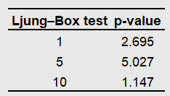
Based on the Table 1-a and 1-b of the Ljung-Box test, the WTI and Brent return series show statistically significant autocorrelation, especially at large lags. With p-values of 5.027 at a lag of 5 and 1.1147 at a lag of 10, the p-values for WTI at lags of 1, 5, and 10 are below typical significance thresholds. This confirms the validity of including autoregressive components in the mean equation and indicates the presence of evidence of autocorrelation in the oil return series.

Table 1-b. Ljung-Box test on Brent returns
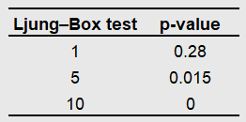
For Brent, while autocorrelation is not statistically significant at lag 1 (p = 0.28), it becomes significant at lag 5 (p = 0.015) and highly significant at lag 10 (p = 0.000004). These findings justify modelling the mean with at least one autoregressive lag.

Table 2-a. AR Model comparison for WTI Returns
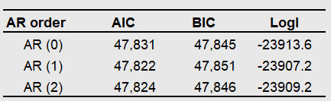

Table 2-b. AR Model comparison for Brent Returns
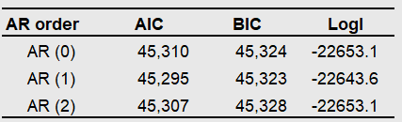
Tables 2-a and 2-b demonstrate the comparison of the AIC, BIC, and log-likelihood models. It is evident that AR (1) significantly improves the fit compared to the model with a constant mean (AR (0)), and a more complex model AR (2). This pattern is observed for both WTI and Brent, indicating that AR (1) effectively and simply reflects most of the autocorrelation structure.
Given these results, the AR (1) model is a well-balanced and empirically sound option for determining the conditional mean in our volatility models (GARCH, EGARCH, and TGARCH).

Table 3-a. Diagnostics tests for estimated conditional variance of Brent
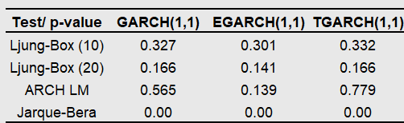
The model adequacy tests are presented in Tables 3-a and 3-b. With lags of 10 and 20, all GARCH models for Brent passed the Ljung-Box test, without showing any noticeable serial correlation in the residuals. Furthermore, ARCH-LM tests show no residual ARCH effects, indicating that the variance specification is sufficient.

Table 3-b. Diagnostics tests for estimated conditional variance of WTI
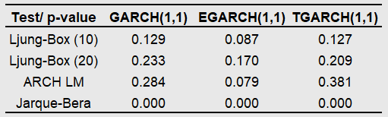
All three models almost pass the diagnostics for WTI returns, although EGARCH is slightly closer to rejecting the null in ARCH-LM test. However, the p-values are still acceptable, especially for GARCH (1,1) and TGARCH (1,1), indicating that the models are generally adequate.
However, the Jarque-Bera test rejects normality for all models and assets. This result is consistent with the heavy-tailed nature of oil returns and aligns with previous studies of oil market volatility.

Table 4-a. OLS Regression coefficients, t-statistics and p-value on WTI’s conditional volatility
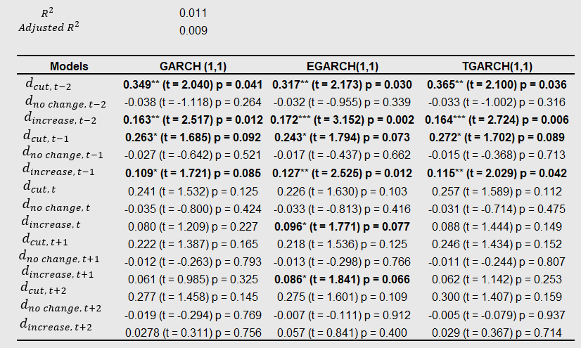

Table 4-b. OLS Regression coefficients, t-statistics and p-value on Brent’s conditional volatility
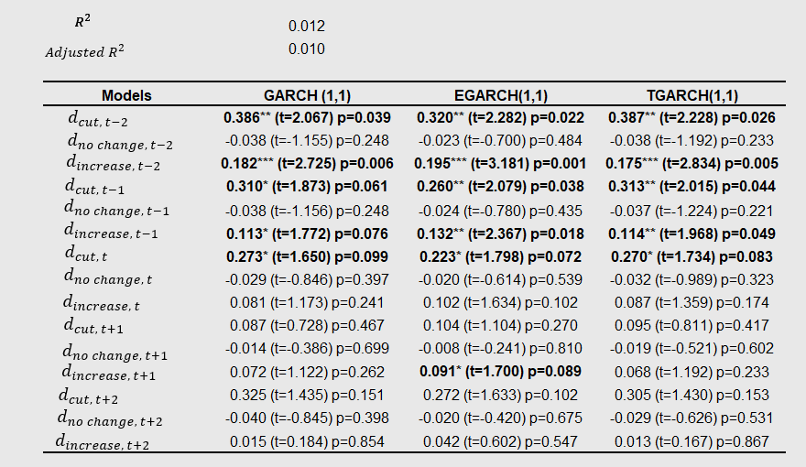

Table 5-a. 25th, 50th, and 75th quantile regression coefficients, t-statistics, p-values on WTI’s conditional volatility
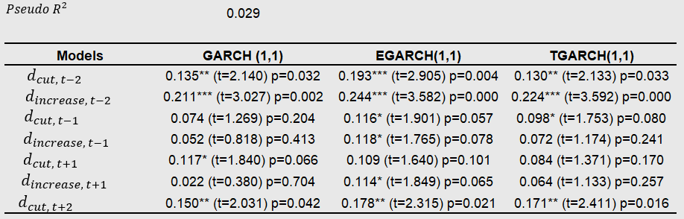
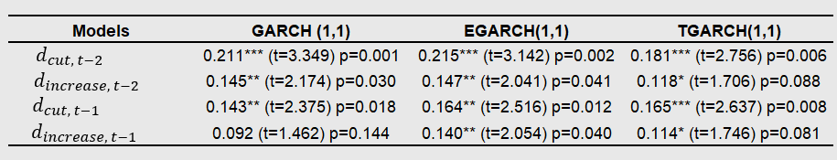
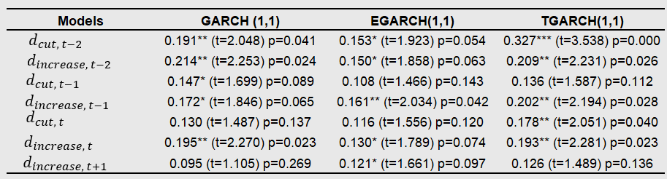

Table 5-b. 25th, 50th, and 75th quantile regression coefficients, t-statistics, p-values on Brent’s conditional volatility
